**Session 1 (unit 1): Flow control and Functions**

|  |  |
| --- | --- |
| Roll No. A016 | Name: Varun Khadayate |
| Program: B-Tech (CSBS) | Division: SY |
| Batch: 1 | Date of Submission: 08-09-2020 |

1. **WAP: to find the largest of three numbers and print the largest number.**

**Ans: CODE:**

#include<iostream>

using namespace std;

int main()

{

int x,y,z;

cout<<"Enter number 1::";

cin>>x;

cout<<"Enter number 2::";

cin>>y;

cout<<"Enter number 3::";

cin>>z;

if(x >= y && x >= z)

cout << "Largest number: " << x;

if(y >= x && y >= z)

cout << "Largest number: " << y;

if(z >= x && z >= y)

cout << "Largest number: " << z;

return 0;

}

**OUTPUT:**

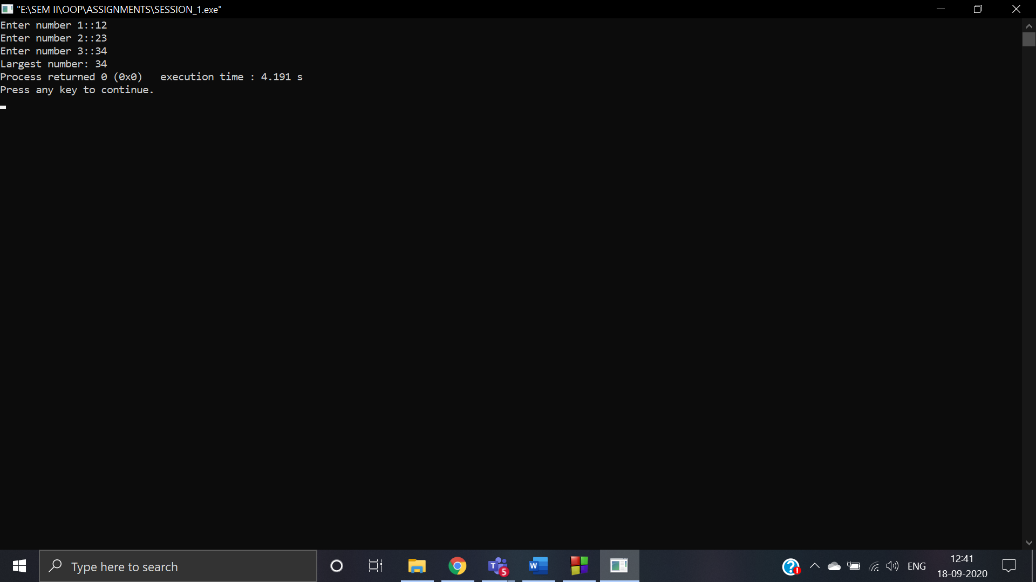

1. **WAP to find the factorial of a number using for loop.**

**ANS:** CODE:

#include <iostream>

using namespace std;

int main()

{

int x,fact = 1;

cout << "Enter a number: ";

cin >> x;

for(int i = 1; i <=x; ++i)

{

fact *= i;

}

cout << "Factorial of " << x << " = " << fact;

return 0;

}

**OUTPUT:**

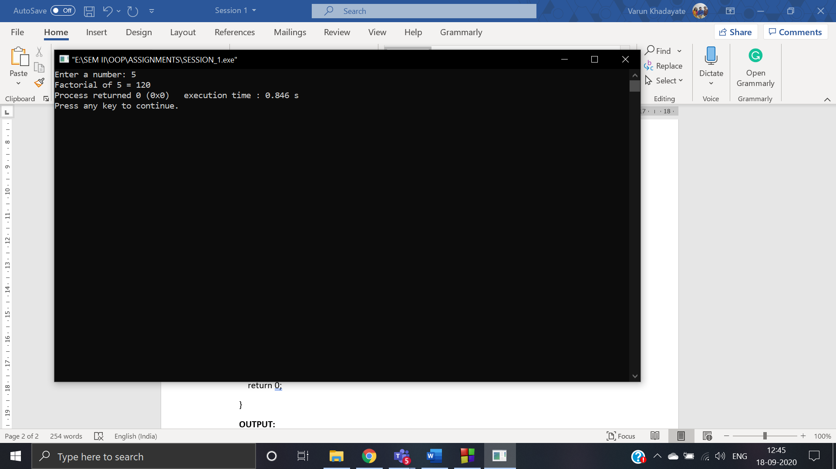

1. **WAP to generate the random numbers in any specific range specified by the user. Ensure that for each run the numbers generated even in the same range are random and not same**

**ANS:**

**CODE:** #include<iostream>

#include<math.h>

#include <time.h>

using namespace std;

void printRandoms(int x,int y,int a)

{

int i;

for (i = 0; i < a; i++)

{

int num = (rand() % (y - x + 1)) + x;

cout<<"\n"<<num;

}

}

int main()

{

int x,y,a;

cout<<"Enter the lower bound number::";

cin>>x;

cout<<"\nEnter the upper bound number::";

cin>>y;

cout<<"\nEnter the number of iteration u need::";

cin>>a;

cout<<"\nThe number in range of "<<x<<" and "<<y<<" for "<<a<<" counts are::";

srand(time(0));

printRandoms(x, y, a);

return 0;

}

**OUTPUT:**

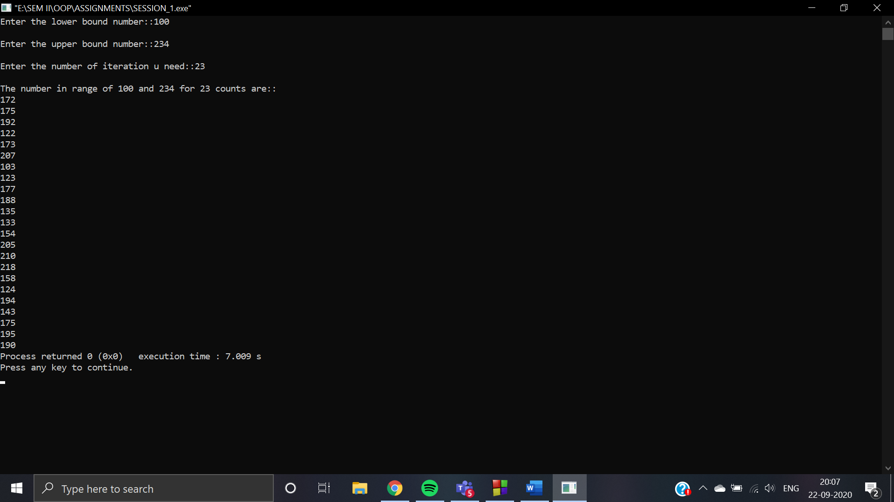

1. **Define a function to calculate power of a number raised to other i.e. a^b using recursion where the numbers 'a' and 'b' are to be entered by the user**

**ANS:** CODE:

#include <iostream>

using namespace std;

int power(int ba, int po) {

if (po == 0)

return 1;

else

return (ba * power(ba, po-1));

}

int main() {

int ba,po;

cout<<"Enter base:";

cin>>ba;

cout<<"Enter Power:";

cin>>po;

cout<<ba<<" raised to the power "<<po<<" is "<<ba<<"^"<<po<<"::"<<power(ba,po);

return 0;

}

**OUTPUT:**

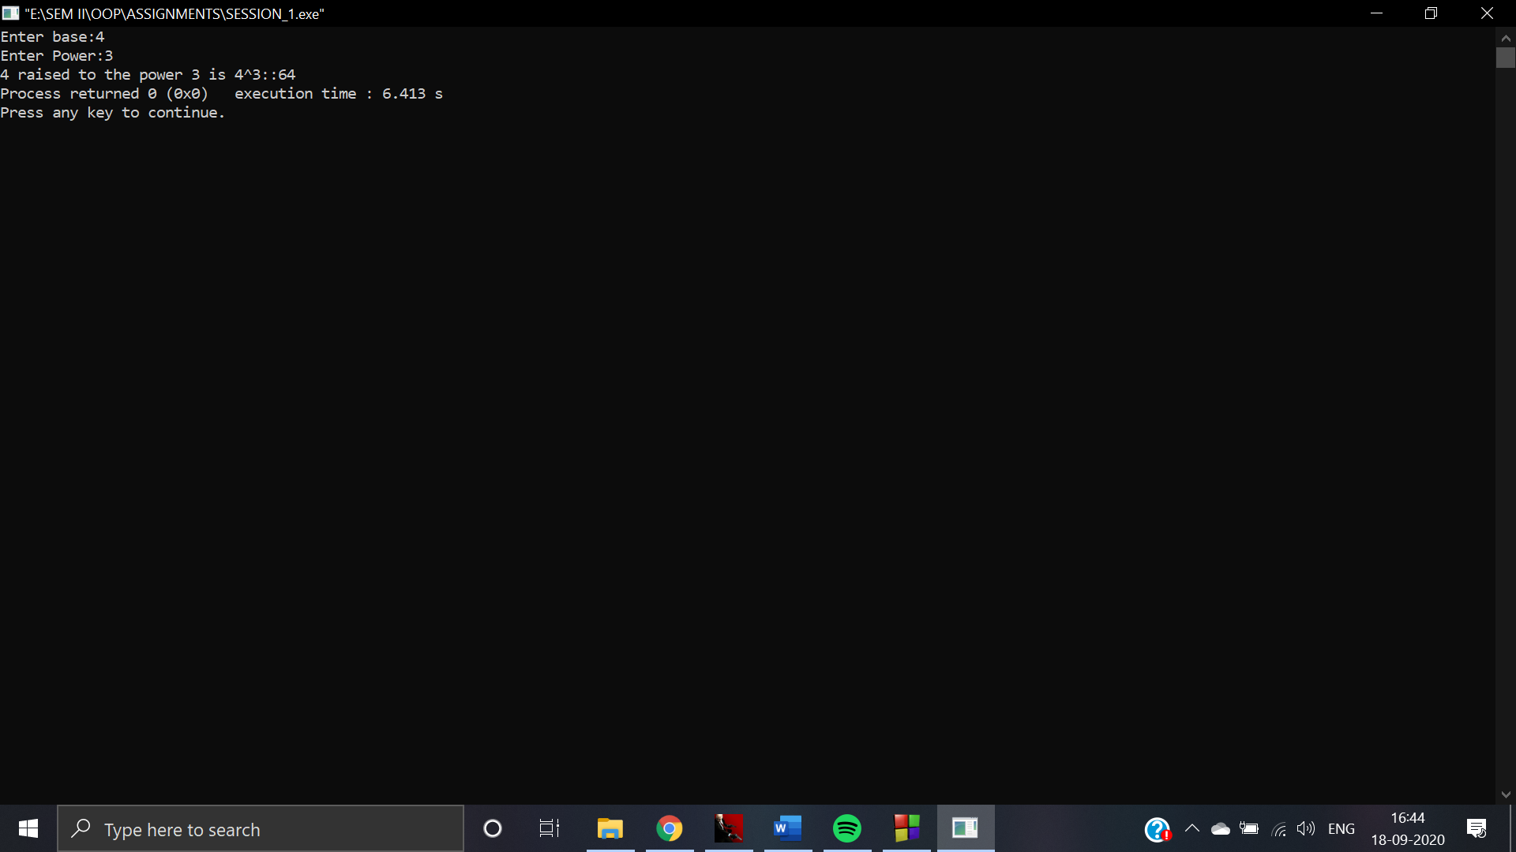

1. **WAP to accept the marks of a student in three subjects and calculate its average using a function.**

**ANS: CODE:** #include <iostream>

using namespace std;

int main()

{

int n, i;

float num[100],sum=0.0, average;

for(i = 0; i < 5; ++i)

{

cout <<"\nEnter marks for subject "<<i + 1 << ":";

cin >> num[i];

sum += num[i];

}

average = sum / 5;

cout << "Average of marks in 5 subjects is = " << average;

return 0;

}

**OUTPUT:**

